**Ideation Phase**

**Define the Problem Statements**

|  |  |
| --- | --- |
| Date | 08 May 2023 |
| Team ID | NM2023TMID14672 |
| Project Name | Uncovering the hidden treasures of the mushroom kingdom :A classification analysis |
| Maximum Marks | 2 Marks |

**Customer Problem Statement Template:**

Create a problem statement to understand your customer's point of view. The Customer Problem Statement template helps you focus on what matters to create experiences people will love.

A well-articulated customer problem statement allows you and your team to find the ideal solution for the challenges your customers face. Throughout the process, you’ll also be able to empathize with your customers, which helps you better understand how they perceive your product or service.

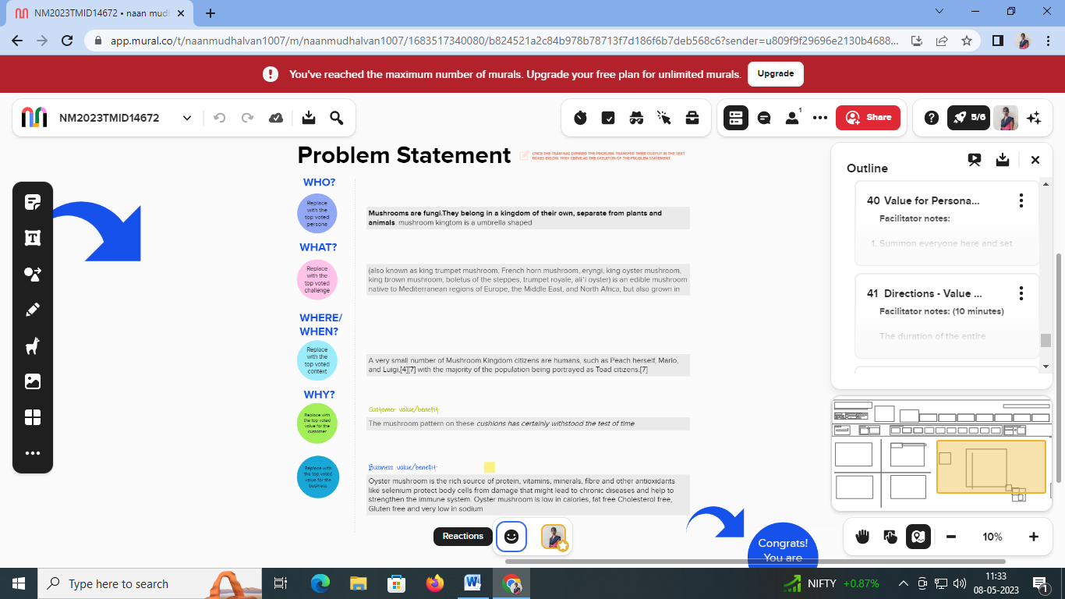

Reference: <https://app.mural.co/t/naanmudhalvan1007/m/naanmudhalvan1007/1683517340080/b824521a2c84b978b78713f7d186f6b7deb568c6?sender=u809f9f29696e2130b4688490>

**Example:**

|  |  |  |  |  |  |
| --- | --- | --- | --- | --- | --- |
| **Problem Statement (PS)** | **I am (Customer)** | **I’m trying to** | **But** | **Because** | **Which makes me feel** |
| PS-1 | I want tot the software mushroom is quality and good product | I am trying to dedect the mushroom | Early effect typically include nausea and excessive yawning | Support a healthy immune system | Mushroom is useful of people |
| PS-2 | Mushroom is useful of people | Mushroom is what is used | Higher doses or stronger mushroom can bring on hallucinations | Which help your body makes antioxidant enzymes to prevent cell damage | Mushroom is useful of positive feel like it |